**Chapter XI Animation**

Animation means giving life to any object in computer graphics. It has the power of injecting energy and emotions into the most seemingly inanimate objects. Computer-assisted animation and computer-generated animation are two categories of computer animation. It can be presented via film or video.

The basic idea behind animation is to play back the recorded images at the rates fast enough to fool the human eye into interpreting them as continuous motion. Animation can make a series of dead images come alive. Animation can be used in many areas like entertainment, computer aided-design, scientific visualization, training, education, e-commerce, and computer art.

Animation Techniques

Animators have invented and used a variety of different animation techniques. Basically there are six animation technique which we would discuss one by one in this section.

Traditional Animation framebyframeframebyframe

Traditionally most of the animation was done by hand. All the frames in an animation had to be drawn by hand. Since each second of animation requires 24 frames filmfilm, the amount of efforts required to create even the shortest of movies can be tremendous.

Keyframing

In this technique, a storyboard is laid out and then the artists draw the major frames of the animation. Major frames are the ones in which prominent changes take place. They are the key points of animation. Keyframing requires that the animator specifies critical or key positions for the objects. The computer then automatically fills in the missing frames by smoothly interpolating between those positions.

Procedural

In a procedural animation, the objects are animated by a procedure − a set of rules − not by keyframing. The animator specifies rules and initial conditions and runs simulation. Rules are often based on physical rules of the real world expressed by mathematical equations.

Behavioral

In behavioral animation, an autonomous character determines its own actions, at least to a certain extent. This gives the character some ability to improvise, and frees the animator from the need to specify each detail of every character's motion.

Performance Based MotionCaptureMotionCapture

Another technique is Motion Capture, in which magnetic or vision-based sensors record the actions of a human or animal object in three dimensions. A computer then uses these data to animate the object.

This technology has enabled a number of famous athletes to supply the actions for characters in sports video games. Motion capture is pretty popular with the animators mainly because some of the commonplace human actions can be captured with relative ease. However, there can be serious discrepancies between the shapes or dimensions of the subject and the graphical character and this may lead to problems of exact execution.

Physically Based DynamicsDynamics

Unlike key framing and motion picture, simulation uses the laws of physics to generate motion of pictures and other objects. Simulations can be easily used to produce slightly different sequences while maintaining physical realism. Secondly, real-time simulations allow a higher degree of interactivity where the real person can maneuver the actions of the simulated character.

In contrast the applications based on key-framing and motion select and modify motions form a pre-computed library of motions. One drawback that simulation suffers from is the expertise and time required to handcraft the appropriate controls systems.

Key Framing

A keyframe is a frame where we define changes in animation. Every frame is a keyframe when we create frame by frame animation. When someone creates a 3D animation on a computer, they usually don’t specify the exact position of any given object on every single frame. They create keyframes.

Keyframes are important frames during which an object changes its size, direction, shape or other properties. The computer then figures out all the in-between frames and saves an extreme amount of time for the animator. The following illustrations depict the frames drawn by user and the frames generated by computer.

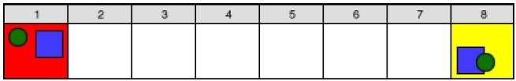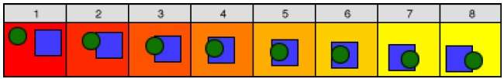

Morphing

The transformation of object shapes from one form to another form is called morphing. It is one of the most complicated transformations.

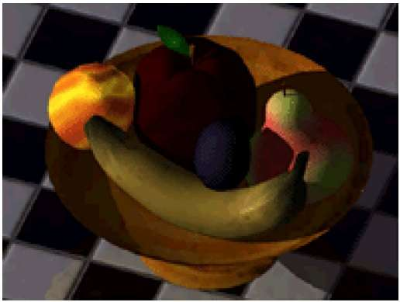

A morph looks as if two images melt into each other with a very fluid motion. In technical terms, two images are distorted and a fade occurs between them.